Lab 3

Ⅰintroduction

In this lab, we will start to learn the ZigBee source code structure, and how to program the ZigBee node by C language

Ⅱ Lab steps and results

Section 1:

In this section, we investigate the source code of the ZigBee stack, we need to read the “Coordinator.c” file and try to understand the structure in the code.

Section 2:

For this section ,we first read the menu of the “Coordinator.c” file to understand the how its written and how the functions works.

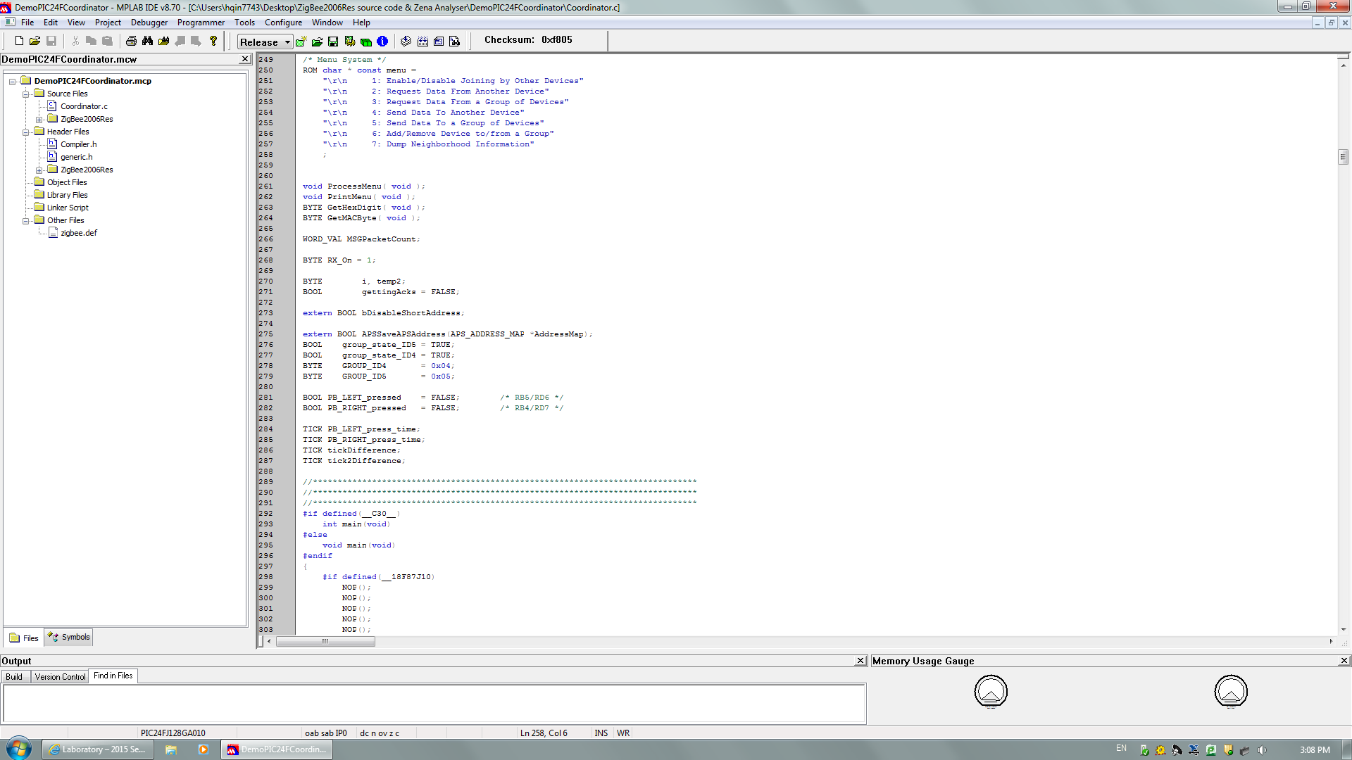

This is the picture of menu.

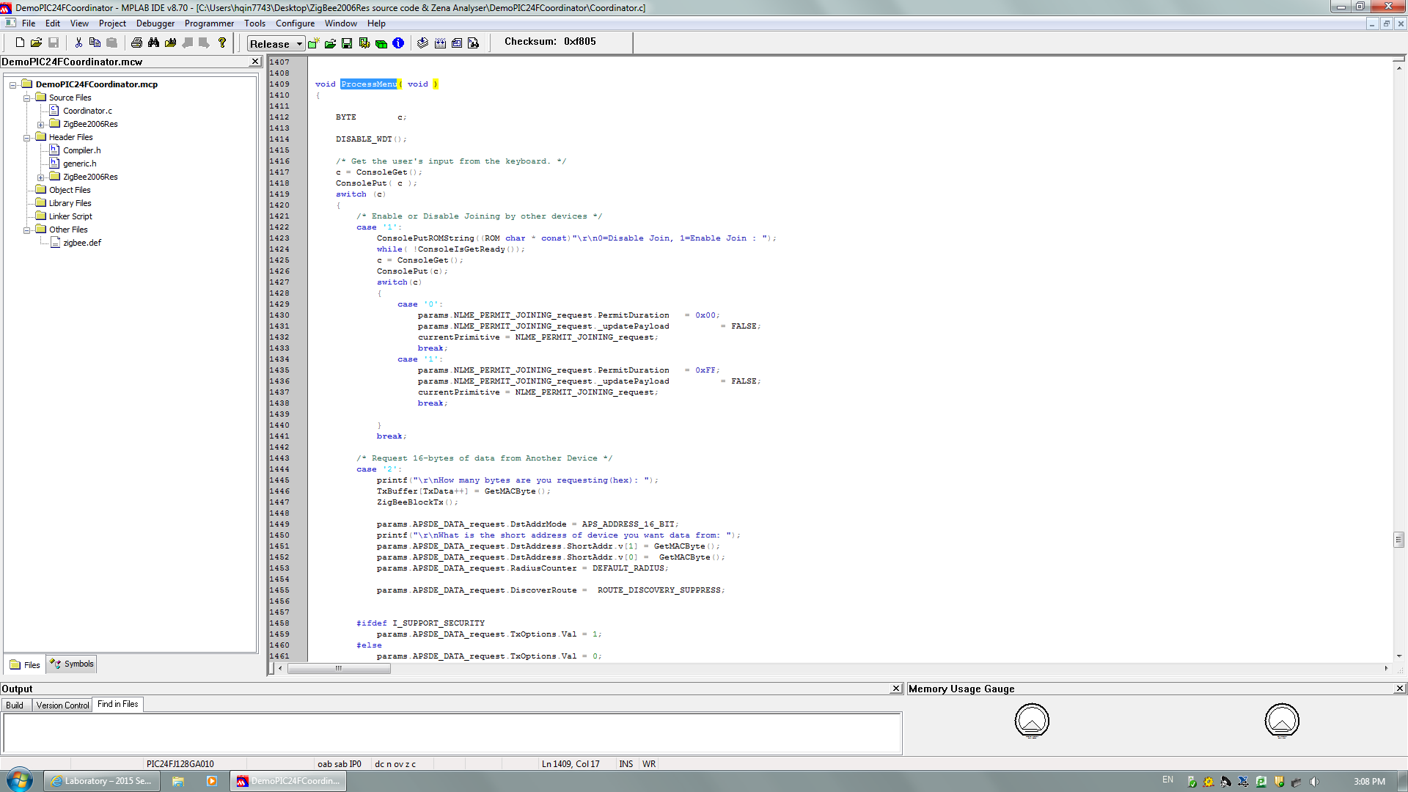

This is the code for one of the cases.

Then ,we try to modify the menu, we add an extra choice on the menu to display a string of characters.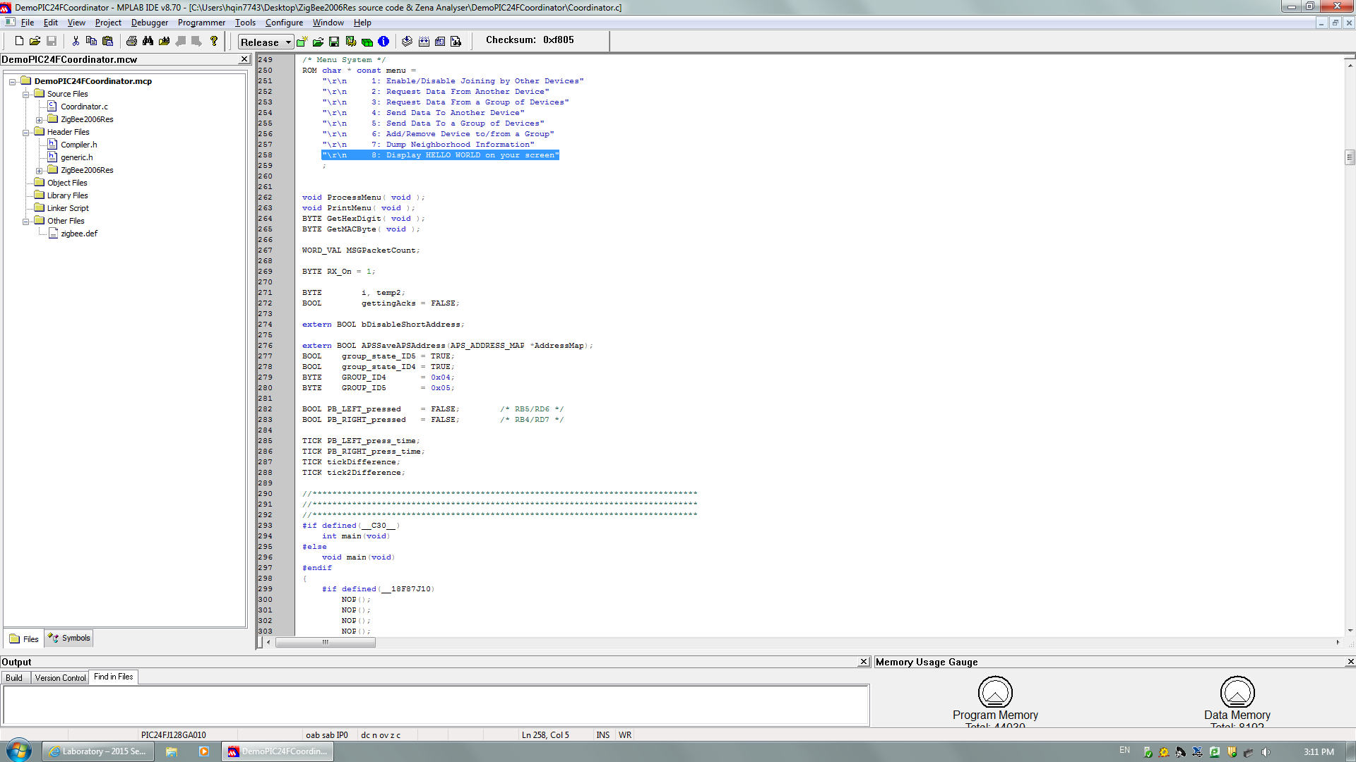

From the picture above, we add case 8 option.

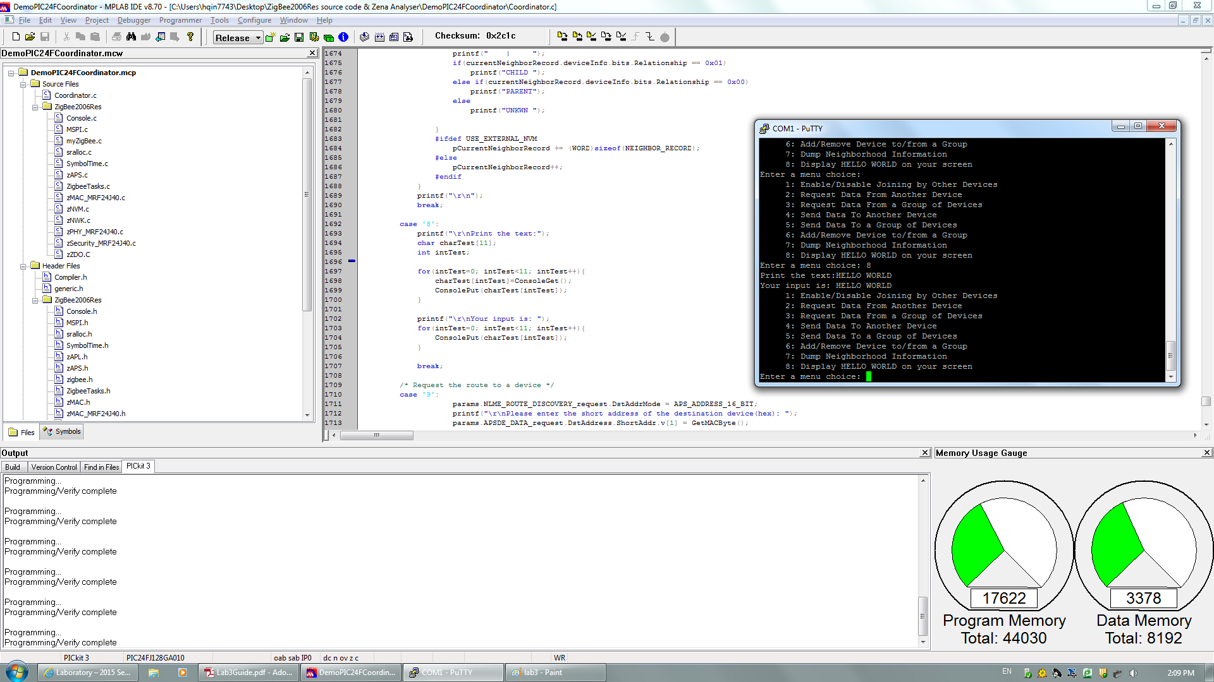

This is our detailed C code for case 8 in order to display a string of characters.

Ⅲ conclusion

In this lab, we learned some information and knowledge about the structure of the source code and did some modification on the functions.

LAB 4

Ⅰintroduction

In this lab, we have two program tasks, first is to calculate and display the sum of 2 numbers and second is convert decimal number to a hex number.

Ⅱ Lab steps and results

Section 1:

In this part we need to calculate and display the sum of two decimal input numbers which from 0 to 9, and turn it into hex value.

The code is displayed as follow.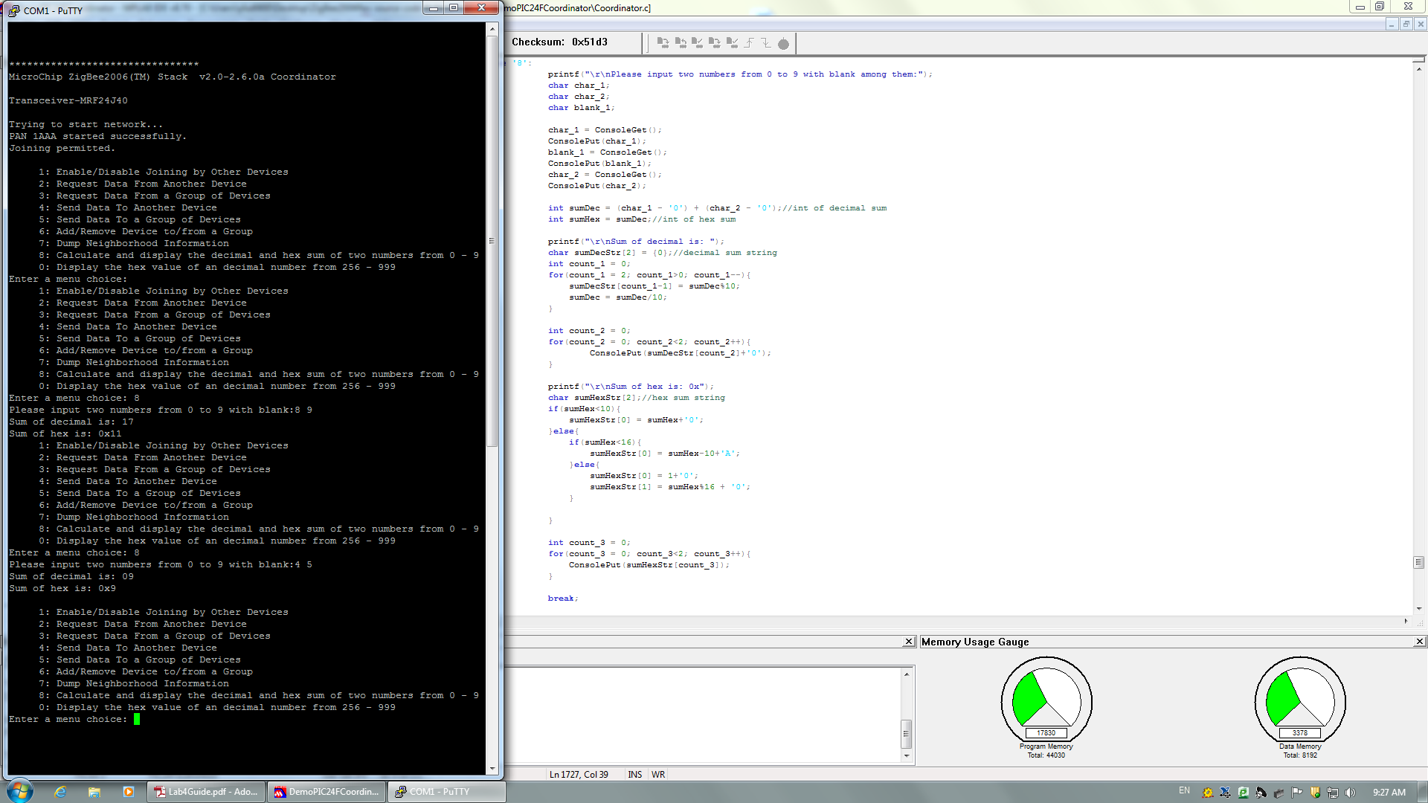

And the outcome is shown in the putty interface, when we input 4 and 5 the sum is displayed as 9 along with its hex value 0x9.

Section 2:

In this section we will try to input a decimal value with wider range(from 256 to 999) and then convert it into hex form and output it.

The code we programmed is shown as follow.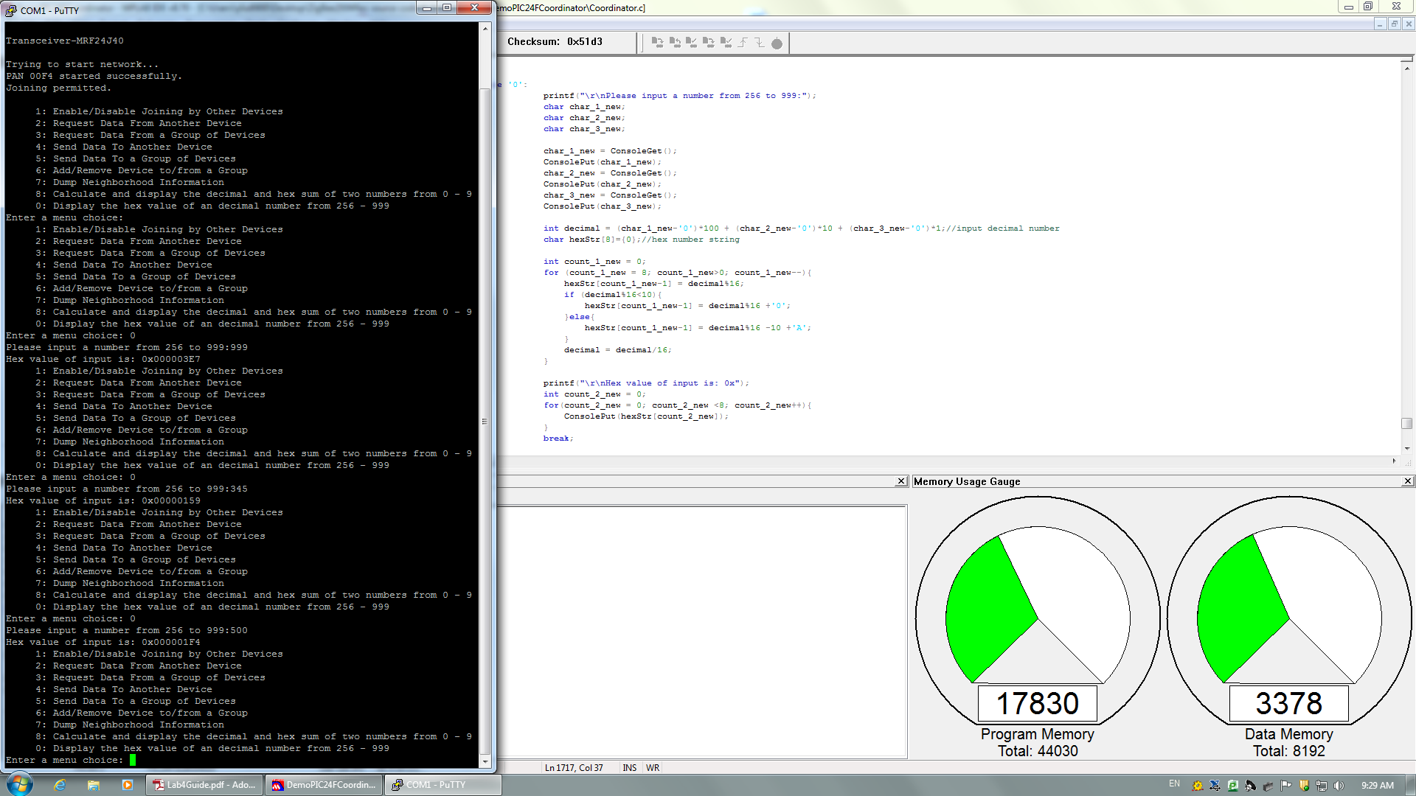

As shown in the putty interface ,when we input decimal value 999, 345 and 500, we get 0x000003E7, 0x00000159 and 0x000001F4 respectively.

Ⅲ conclusion

In this lab, we reviewed the C language and used that to add some new function for the source code.